

**Sales Manager**

**DETAIL DESIGN DOCUMENT**

**Screen design**

**Project Code:**

**Document Code: Sales Manager-DD – v1.0**

**<Location, issued date of the Document>**

**RECORD OF CHANGE**

#### *A - Added M - Modified D – Deleted

|  |  |  |  |  |
| --- | --- | --- | --- | --- |
| Effective Date | Changed Items | A* M, D | Change Description | New Version |
|  |  |  |  |  |
|  |  |  |  |  |
|  |  |  |  |  |
|  |  |  |  |  |
|  |  |  |  |  |
|  |  |  |  |  |
|  |  |  |  |  |
|  |  |  |  |  |
|  |  |  |  |  |
|  |  |  |  |  |
|  |  |  |  |  |
|  |  |  |  |  |
|  |  |  |  |  |

**SIGNATURE PAGE**

**ORIGINATOR:**<Name> Vũ Công Hoàng <Date> 03/12/2018

#### <Position>member

**REVIEWERS:** <Name> <Date>

#### <Position>

<Name, if it’s needed> <Date>

<Position>

**APPROVAL:** <Name> <Date>

#### <Position>

Contents

1 INTRODUCTION 5

1.1 Purpose 5

1.2 Overview 5

1 SCREEN FLOW 6

1.1 Screen Login 7

1.2 Screen register 9

1.3 Home screen 11

1.4 Detail screen 13

1.5 User Infor screen 15

1.6 Logout Screen 17

### INTRODUCTION

## Purpose

This part will give general description of the document including:

* + - *Purpose of document.*
    - *What are contained in the doc*
    - *Reader of document*
    - *Other description about scope of document, limitation,.*

## Overview

This application allows users to search for places to book tour

### SCREEN FLOW

<List of screen>

|  |  |  |
| --- | --- | --- |
| **No** | **Screen Name** | **Description** |
| 1 | Login screen | When the user finishes all the steps, click the button to continue creating the account without an account |
| 2 | Registration screen | Enter all the fields then click the register button if successful registration will appear successful registration message to cancel the registration. |
| 3 | Home screen | Login success,  Click on Image or Text Move to the details screen |
| 4 | Detail screen | Show pictures and details of Item. And when click button ADD TO CARD show message Thêm Thành Công |
| 5 | User Infor screen | Show account information. |
| 6 | Logout screen | When user click button “Thông Tin Tài Khoản” move to user infor screen.  When user click Button “Đăng Xuất” logout and move to login screen. |

## Screen Login

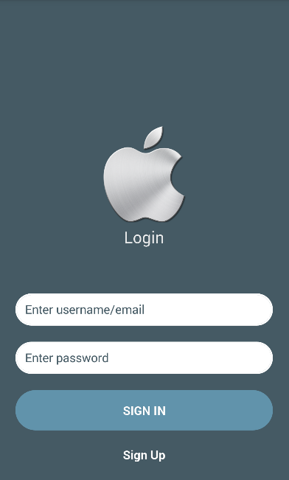

**Image 1: screen Login**

|  |  |  |  |  |  |
| --- | --- | --- | --- | --- | --- |
| **No** | **Component Name** | **Required** | **Format** | **Reference** | **Note** |
|  | 1 field for input email/username |  |  | * Use Text : * Text : Email/ Username * Use TextInput : * fontSize: 20 * Color :#FFFFFF * Backgroudcolor:# 1c313a |  |
|  | 1 field for input password |  |  | * Use Text : * Text : Password * Use TextInput : * fontSize: 20   Color :#FFFFFF |  |
|  | 1 button for login |  |  | * Use Buttom : * Text : Login * fontSize :15 * Color :#FFFFFF * Background :#FF0000   textAlign="center". |  |
|  | 1 button for register |  |  | * Use Buttom : * Text : Login * fontSize :15 * Color :#FFFFFF * Background :#FF0000   textAlign="center". |  |

## Screen register

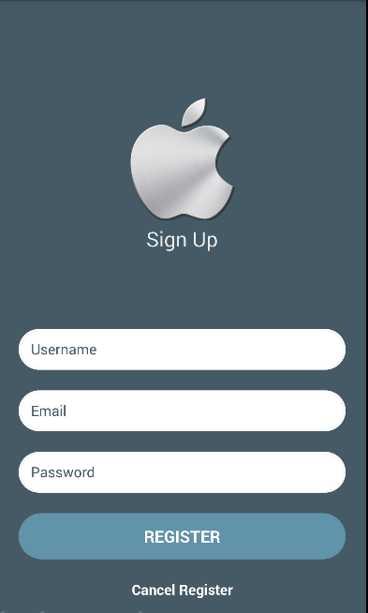

**Image 2: Screen register**

|  |  |  |  |  |  |
| --- | --- | --- | --- | --- | --- |
| **No** | **Component Name** | **Required** | **Format** | **Reference** | **Note** |
|  | 1 field for input username |  |  | * Use Text : * Text : Username * Use TextInput : * fontSize: 20 * Color :#FFFFFF |  |
|  | 1 field for input email |  |  | * Use Text : * Text : Email * Use TextInput : * fontSize: 20 * Color :#FFFFFF |  |
|  | 1 field for input password |  |  | * Use Text : * Text : Email * Use TextInput : * fontSize: 20 * Color :#FFFFFF |  |
|  | 1 button |  |  | * Use Buttom : * Text : Login * fontSize :15 * Color :#FFFFFF * Background :#FF0000 * textAlign="center". |  |
|  | 1 Text |  |  | * Use Text : * Text : Cancel Register * fontSize :15 * Color :#FFFFFF   textAlign="center". |  |

## Home screen

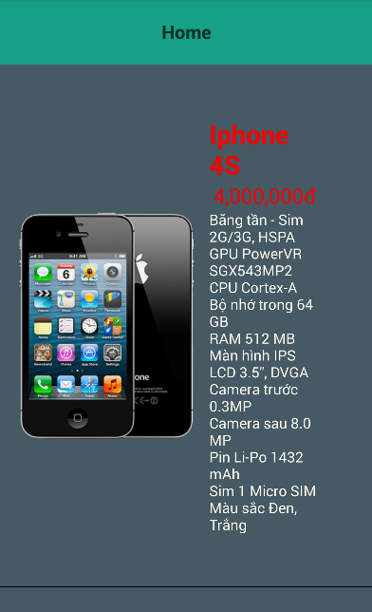

**Image 3: Home screen**

|  |  |  |  |  |  |
| --- | --- | --- | --- | --- | --- |
| **No** | **Component Name** | **Required** | **Format** | **Reference** | **Note** |
|  | **1 Header** |  |  | * Use Navigator : * Backgroudcolor: #16a085 * fontSize: 17 * TextAlign="center". |  |
|  | **1 ListView** |  |  | * Use listview | Show image and name of item |

## Detail screen

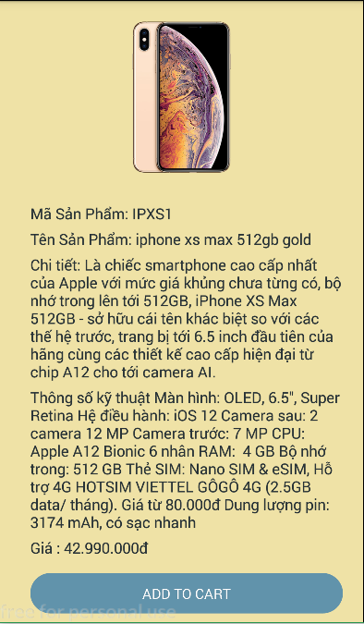

**Image 4: detail page**

|  |  |  |  |  |  |
| --- | --- | --- | --- | --- | --- |
| **No** | **Component Name** | **Required** | **Format** | **Reference** | **Note** |
|  | images |  |  | * Use image | Image of item |
|  | Text |  |  | * Use text : * fontSize : 20 * color : #FFFFFF | Detail infor of item |
|  | Button |  |  | * Use button: * Use Text: * Text : ADD TO CARD * Color :# FFFFFF * fontSize : 25 * backgroundcolor: * # 6193ab | When user click show message “Thêm thành công” |

## User Infor screen

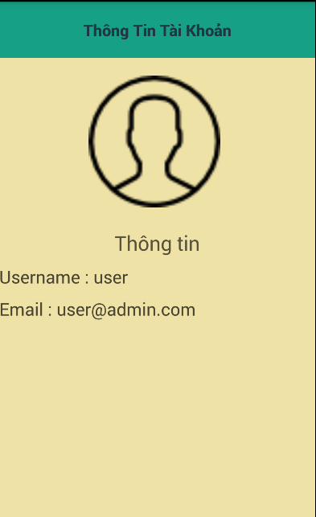

**Image 5: user infor screen**

|  |  |  |  |  |  |
| --- | --- | --- | --- | --- | --- |
| **No** | **Component Name** | **Required** | **Format** | **Reference** | **Note** |
|  | Header |  |  | * Use Navigator : * Text : Thông tin tài khoản * fontSize: 25 * Color :#FFFFFF * backGroundColor:   # 16a085 |  |
|  | Text |  |  | * Use Text : * fontSize: 20   Color :#FFFFFF | Show infor detail of account |
|  | Image |  |  | * Use Image. | image default of account |

## Logout Screen

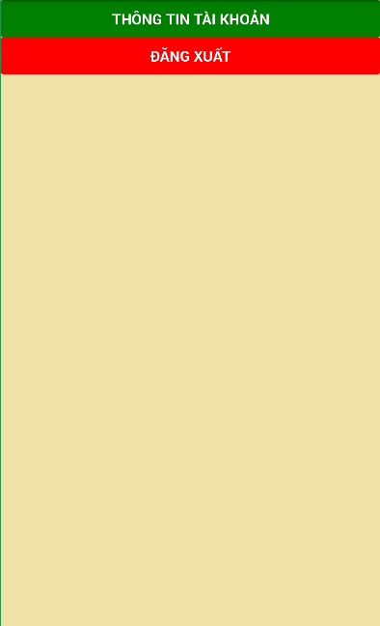

**Image 6 : logout Screen**

|  |  |  |  |  |  |
| --- | --- | --- | --- | --- | --- |
| **No** | **Component Name** | **Required** | **Format** | **Reference** | **Note** |
|  | button |  |  | * Use button : * Text :thông tin tài khoản   fontSize: 20   * Color :#FFFFFF * BackGroundColor:green | When click on it will move to user infor screen. |
|  | button |  |  | * Use button : * Text :đăng xuất   fontSize: 20   * Color :#FFFFFF   BackGroundColor:green | When click on it will logout and move to login screen |

--------------------------- End Document -----------------------